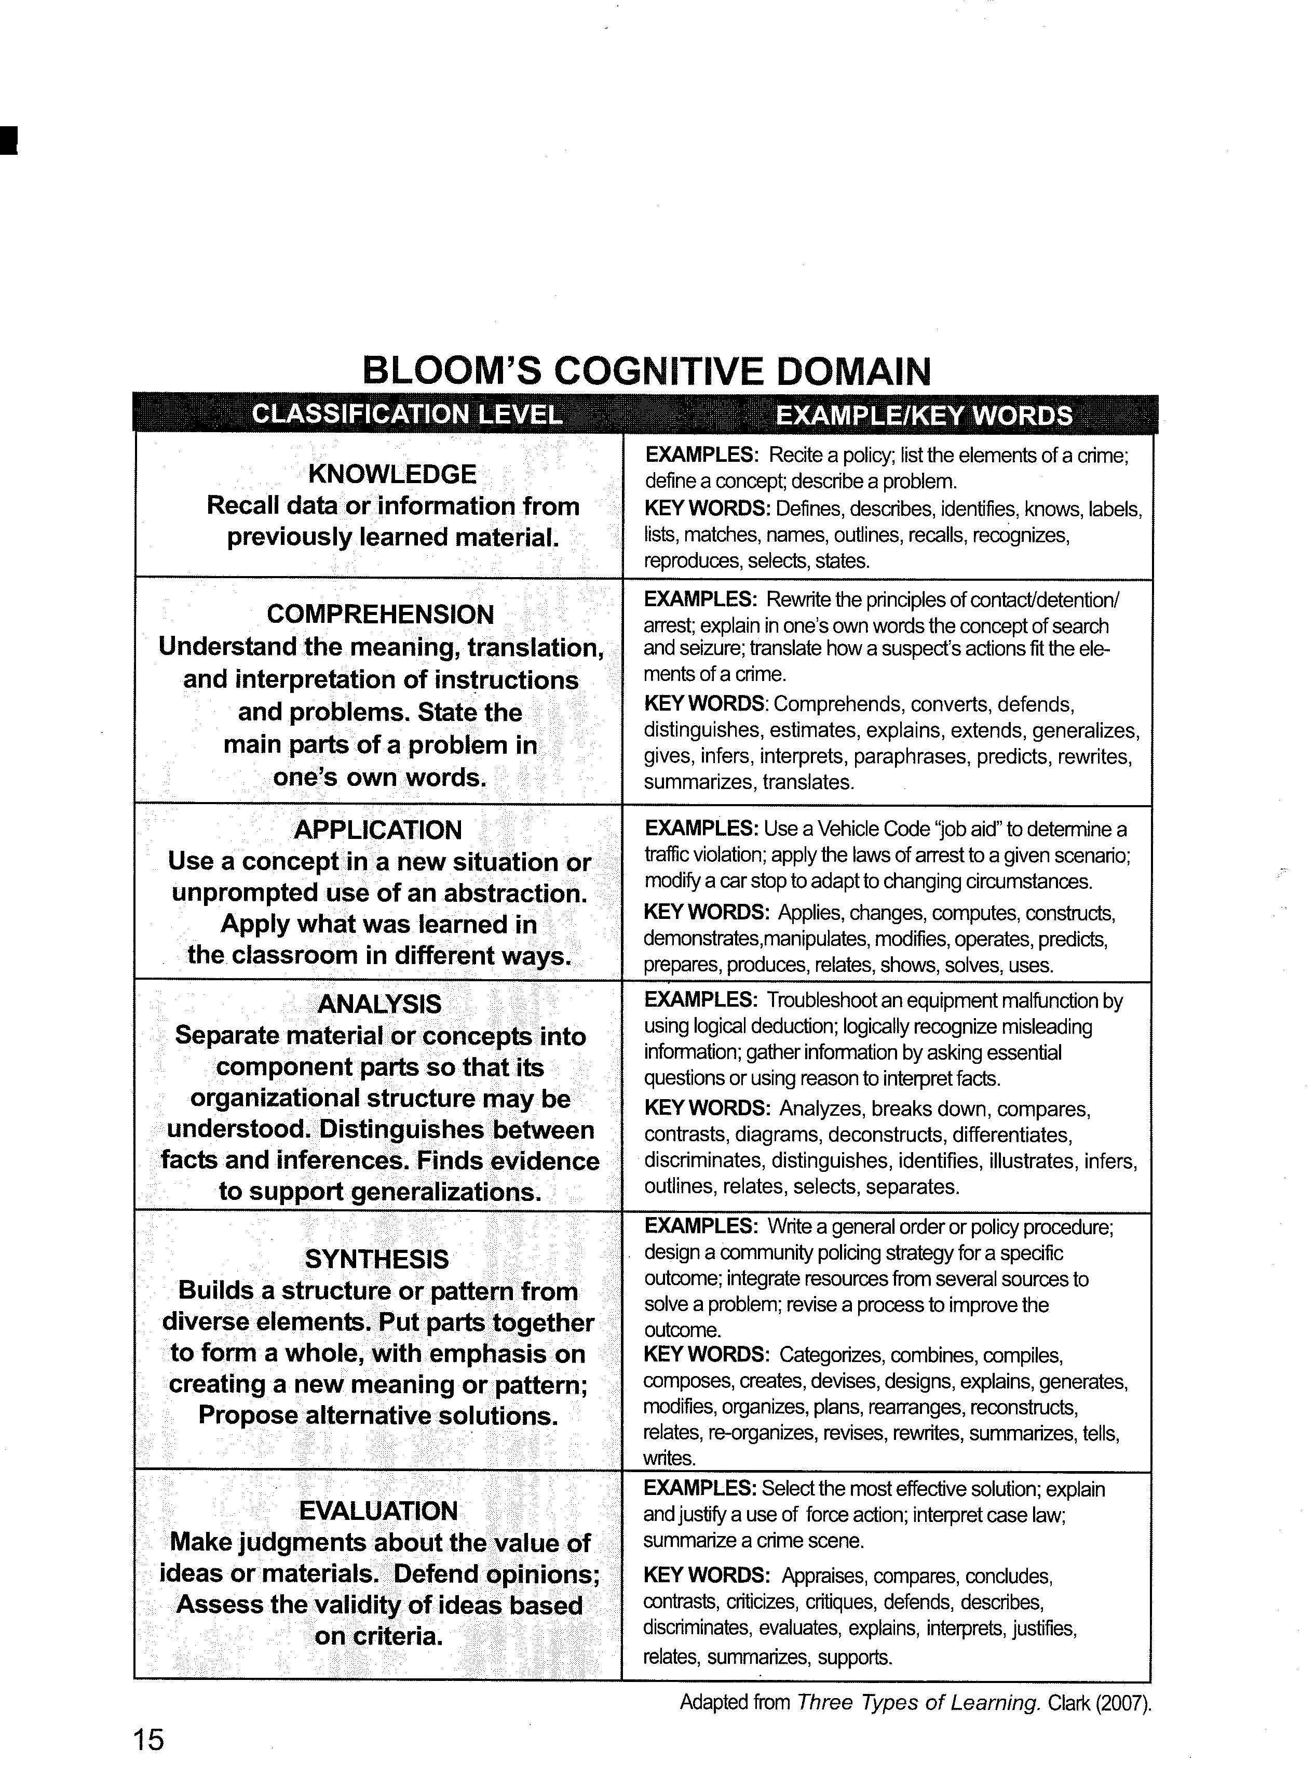
Taken from: Dischinger, Todd. 2008. Academy Instructor Certification Course Manual, California Commission on Peace Officer Standards and Training.

